**AIRLINE RESERVATION SCHEMA**

**ER DIAGRAM:**

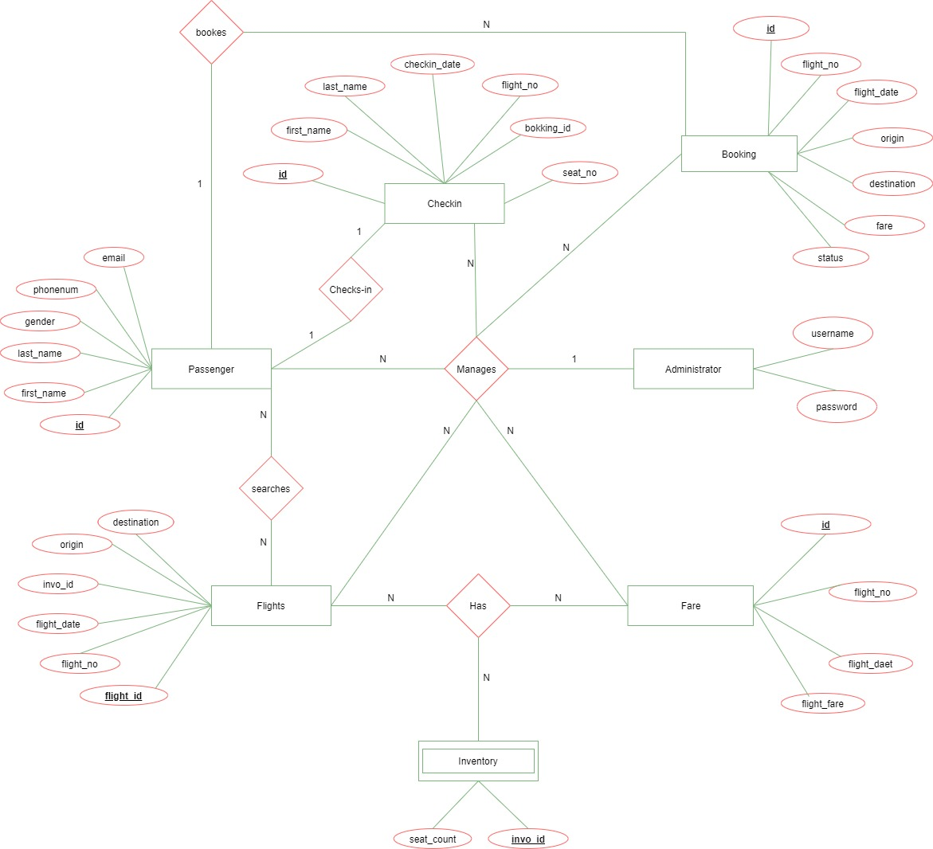

**CREATING FARE SCHEMA**

**1) CONNECTING TO THE DATABASE :->**

While connecting to the database you have to provide your credentials. And the command for connecting the database is, “conn username/password”.

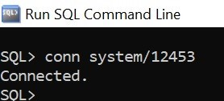

**2) CREATING TABLESPACES :->**

Here we are creating a TABLESPACE. These are used for dividing a single table data to multiple locations, so that in data loss we don’t loss all of the data.

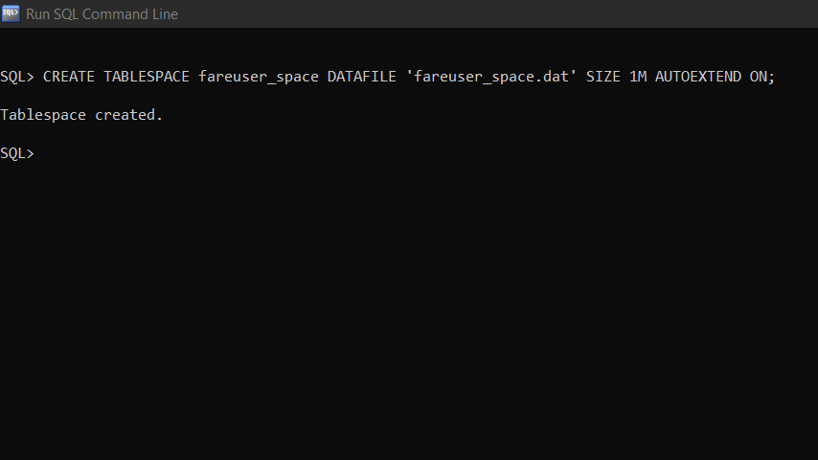

**3) CREATING USERS & GRANTING PERMISSION :->**

Here we are creating a user credentials and assigning a TABLESPACE for the user. You can create multiple users in a database.

Create a new user in Oracle:

CREATE **USER** fareuser **IDENTIFIED** BY fareuser1 DEFAULT TABLESPACE fareuser_space QUOTA unlimited on fareuser_space;

**Note**: In oracle, a schema is created when a user is created.

GRANT create session TO fareuser;

GRANT create table TO fareuser;

GRANT create sequence TO fareuser;

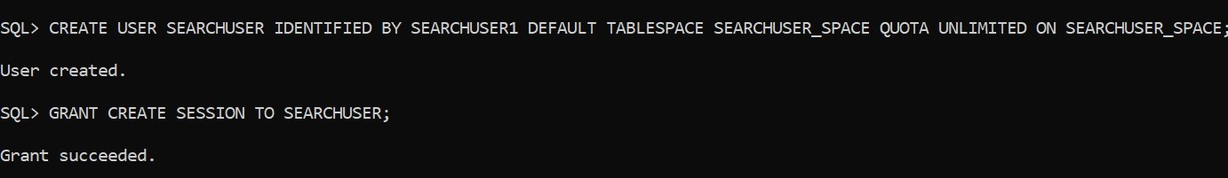

**4) DISCONNECT FROM SYSTEM ACCOUNT and CONNECT TO FAREUSER:->**

Sql>exit

C:\>sqlplus fareuser/fareuser1

**5) CREATING TABLES & SEQUENCES :->**

create table fare (id number(19) primary key, fare varchar2(255), flight_date varchar2(255), flight_number varchar2(255));

create sequence fare_sq start with 1 increment by 1;

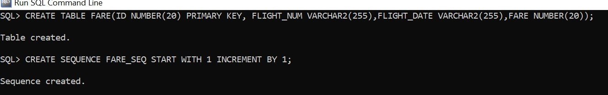

**6) INSERT DATA :->**

insert into fare(id, fare, flight_date, flight_number) values (fare_sq.nextVal, '100', '22-JAN-16', 'BF100');

insert into fare(id, fare, flight_date, flight_number) values (fare_sq.nextVal, '101', '22-JAN-16', 'BF101');

insert into fare(id, fare, flight_date, flight_number) values (fare_sq.nextVal, '102', '22-JAN-16', 'BF102');

insert into fare(id, fare, flight_date, flight_number) values (fare_sq.nextVal, '103', '22-JAN-16', 'BF103');

insert into fare(id, fare, flight_date, flight_number) values (fare_sq.nextVal, '104', '22-JAN-16', 'BF104');

insert into fare(id, fare, flight_date, flight_number) values (fare_sq.nextVal, '105', '22-JAN-16', 'BF105');

insert into fare id, fare, flight_date, flight_number) values (fare_sq.nextVal, '106','22-JAN-16', 'BF106');

commit;

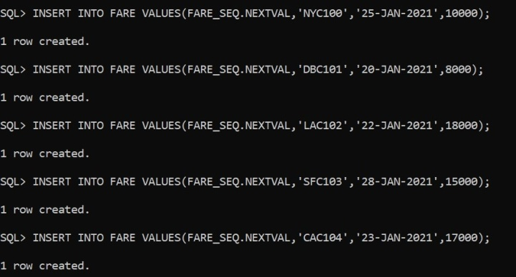

**7) DROPPING USERS (**Optional**) :->**

If required, we can drop the table and sequence

drop table fare cascade constraints; drop sequence fare_seq;

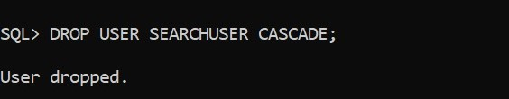

**CREATING SEARCH SCHEMA**

**1) CONNECTING TO THE DATABASE :->**

Connect to database (ignore if already connected)

C:\>sqlplus system/manager@xe

OR

SQL> conn username/password;

**2) CREATING TABLESPACES :->**

Here we are creating a TABLESPACE. These are used for dividing a single table data to multiple locations, so that in data loss we don’t loss all the data.

**3) CREATING USERS & GRANTING PERMISSION :->**

Here we are creating a user credentials and assigning a TABLESPACE for the user. You can create multiple users in a database.

Create a new user in Oracle

CREATE USER searchuser IDENTIFIED BY searchuser1;

Grant permissions

GRANT create session TO searchuser;

GRANT create table TO searchuser;

GRANT create sequence TO searchuser;

**4) DISCONNECT FROM SYSTEM ACCOUNT and CONNECT TO SEARCH USER:->**

Sql>exit

SQL> conn searchuser/searchuser1;

**5) CREATING TABLES & SEQUENCES :->**

create sequence fare_sq start with 1 increment by 1; create sequence flight_sq start with 1 increment by 1; create sequence invo_sq start with 1 increment by 1;

create table fare (fare_idnumber(19) primary key, currency varchar2(255), fare varchar2(255));

create table inv (inv_idnumber(19) primary key, count number(10) not null);

create table flight (id number(19) primary key, origin varchar2(255), destination varchar2(255), flight_number varchar2(255), flight_date varchar2(255),

fare_idnumber(19) references fare(fare_id), inv_id number(19) references inventory(inv_id));

**6) INSERT DATA :->**

insert into invo (seat count, inv_id) values (100, invo_sq.nextVal);

insert into invo (seat count, inv_id) values (100, invo_sq.nextVal);

insert into invo (seat count, inv_id) values (100, invo_sq.nextVal);

insert into invo (seat count, inv_id) values (100, invo_sq.nextVal);

insert into invo (seat count, inv_id) values (100, invo_sq.nextVal);

insert into invo (seat count, inv_id) values (100, invo_sq.nextVal);

insert into invo (seat count, inv_id) values (100, invo_sq.nextVal);

insert into flight (id, flight_number, origin, destination, flight_date, fare_id, inv_id) values (flight_seq.nextVal, 'BF100', 'SEA', 'SFO', '22-JAN-16', 1, 1);

insert into flight (id, flight_number, origin, destination, flight_date, fare_id, inv_id) values (flight_seq.nextVal, 'BF101', 'NYC', 'SFO', '22-JAN-16', 2, 2);

insert into flight (id, flight_number, origin, destination, flight_date, fare_id, inv_id) values (flight_seq.nextVal, 'BF102', 'CHI', 'SFO', '22-JAN-16', 3, 3);

Here we can insert as much data as we want.

**commit**;

**7) PRINTING TABLES :->**

SELECT * FROM "SEARCH USER"."INVENTORY";

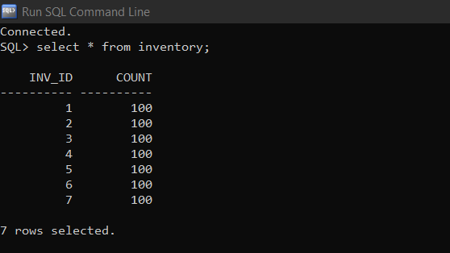

**SELECT * FROM "SEARCHUSER"."FLIGHT’’;**

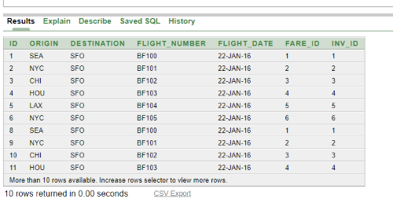

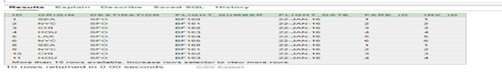

**8) DROPPING USERS :->**

drop table fare cascade constraints;

drop table invo cascade constraints;

drop table flight cascade constraints;

drop sequence fare_sq;

drop sequence flight_sq;

drop sequence invo_sq;

**CREATING BOOKING SCHEMA**

**1) CONNECTING TO THE DATABASE :->**

Connect to database (ignore if already connected)

C:\>sqlplus system/manager@xe

OR

SQL> conn username/password;

**2) CREATING TABLESPACES :->**

Here we are creating a TABLESPACE. These are used for dividing a single table data to multiple locations, so that in data loss we don’t loss all the data.

**3) CREATING USERS & GRANTING PERMISSION :->**

Here we are creating a user credentials and assigning a TABLESPACE for the user. You can create multiple users in a database.

Create a new user in Oracle

CREATE USER bookinguser IDENTIFIED BY bookinguser1;

Grant permissions

GRANT create session TO bookinguser;

GRANT create table TO bookinguser;

GRANT create sequence TO bookinguser;

**4) DISCONNECT FROM SYSTEM ACCOUNT and CONNECT TO SEARCH USER:->**

Sql>exit

C:\>sqlplus bookinguser/bookinguser1;

**5) CREATING TABLES & SEQUENCES :->**

create sequence booking_sq start with 1 increment by 1;

create sequence invo_sq start with 1 increment by 1;

create sequence passenger_sq start with 1 increment by 1;

create table booking_record (id number(19) primary key, booking_date timestamp, destination varchar2(255), fare varchar2(255), flight_date varchar2(255), flight_number varchar2(255), origin varchar2(255), status varchar2(255));

create table passenger (id number(19) primary key, first_name varchar2(255), gender varchar2(255), last_name varchar2(255), booking_id number(19) references booking_record(id));

**6) INSERT DATA :->**

insert into booking_record (id number, booking_date , destination , fare , flight_date , flight_number, origin , status)values(1,’2017-06-06’,’nyc’,’sfo’,101,’22-jan-16’,’BF-101’,’BOOKING CONFIRMED’);

insert into passenger (id, first_name , gender , last_name,booking_id) values (1,’Gean’,’Franc’,’Male’,1);

commit;

**7) PRINTING TABLES :->**

Read data from BOOKINGUSER schema

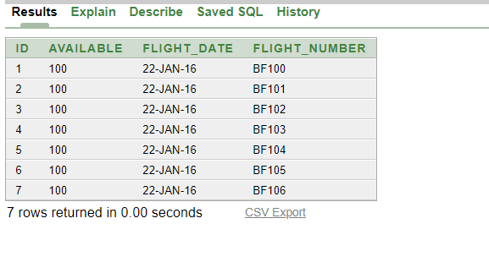

SELECT * FROM "BOOKINGUSER"."BOOKING_RECORD";

|  |  |  |  |  |  |  |  |
| --- | --- | --- | --- | --- | --- | --- | --- |
| ID | BOOKING_DATE | ORIGIN | DESTINATION | FARE | FLIGHT_DATE | FLIGHT_NUMBER | STATUS |
|  |  |  |  |  |  |  |  |
| 1 | 2017-06-06 | NYC | SFO | 101 | 22-JAN-21 | BF101 | **BOOKING_CONFIRMED** |
|  | 20:46:01 |  |  |  |  |  |  |

SELECT * FROM "BOOKINGUSER"."PASSENGER";

|  |  |  |  |  |
| --- | --- | --- | --- | --- |
| ID | FIRST_NAME | LAST_NAME | GENDER | BOOKING_ID |
| 1 | NITISH | SINGH | Male | 1 |

**CREATING CHECKIN SCHEMA**

**1) CONNECTING TO THE DATABASE :->**

Connect to database (ignore if already connected)

C:\>sqlplus system/manager@xe

OR

SQL> conn username/password;

**2) CREATING TABLESPACES :->**

Here we are creating a TABLESPACE. These are used for dividing a single table data to multiple locations, so that in data loss we don’t loss all the data.

**3) CREATING USERS & GRANTING PERMISSION :->**

Here we are creating a user credentials and assigning a TABLESPACE for the user. You can create multiple users in a database.

Create a new user in Oracle

CREATE USER checkinuser IDENTIFIED BY checkinuser1;

Grant permissions

GRANT create session TO checkinuser;

GRANT create table TO checkinuser;

GRANT create sequence TO checkinuser;

**4) DISCONNECT FROM SYSTEM ACCOUNT and CONNECT TO SEARCH USER :->**

Sql>exit

C:\>sqlplus checkinuser/checkinuser1;

**5) CREATING TABLES & SEQUENCES :->**

create sequence checkin_seq start with 1 increment by 1;

create table check_in_record (id number(19)primary key, booking_id number(19) not null, check_in_time timestamp, first_name varchar2(255), flight_date varchar2(255), flight_number varchar2(255), last_name varchar2(255), seat_numbervarchar2(255));

**6) INSERT DATA :->**

No need to insert data manually

**7) PRINTING TABLES :->**

Read data from CHECKINUSER schema

SELECT * FROM "CHECKINUSER"."CHECK_IN_RECORD";

|  |  |  |  |  |  |  |  |
| --- | --- | --- | --- | --- | --- | --- | --- |
| **ID** | **BOOKING_ID** | **CHECK_IN_TIME** | **FIRST_** | **LAST_NAME** | **FLIGHT_DATE** | **FLIGHT_NUMBER** | **SEAT_NUMBER** |
|  |  |  | **NAME** |  |  |  |  |
|  |  |  |  |  |  |  |  |
| 1 | 1 | 2017-06-06 | Gean | Franc | 22-JAN-16 | BF101 | 28A |
|  |  | 21:18:46 |  |  |  |  |  |





**FORMS**

**FLIGHT**

Flight date :

Flight number :

ID :

Fare :

Inv_ID :

**BOOKING RECORD**

Id :

Booking date :

Destination :

Fare :

Flight Date :

Flight Number :

Origin :

Status :



**PASSENGER**

Id :

First Name :

Gender : male female

Last Name :

Booking Id :

Booking Record :



**CHECKIN RECORD**

Id :

Booking Id :

Checkin Time :

First Name :

Last Name :

Flight Date :

Flight Number :

Seat Number :

